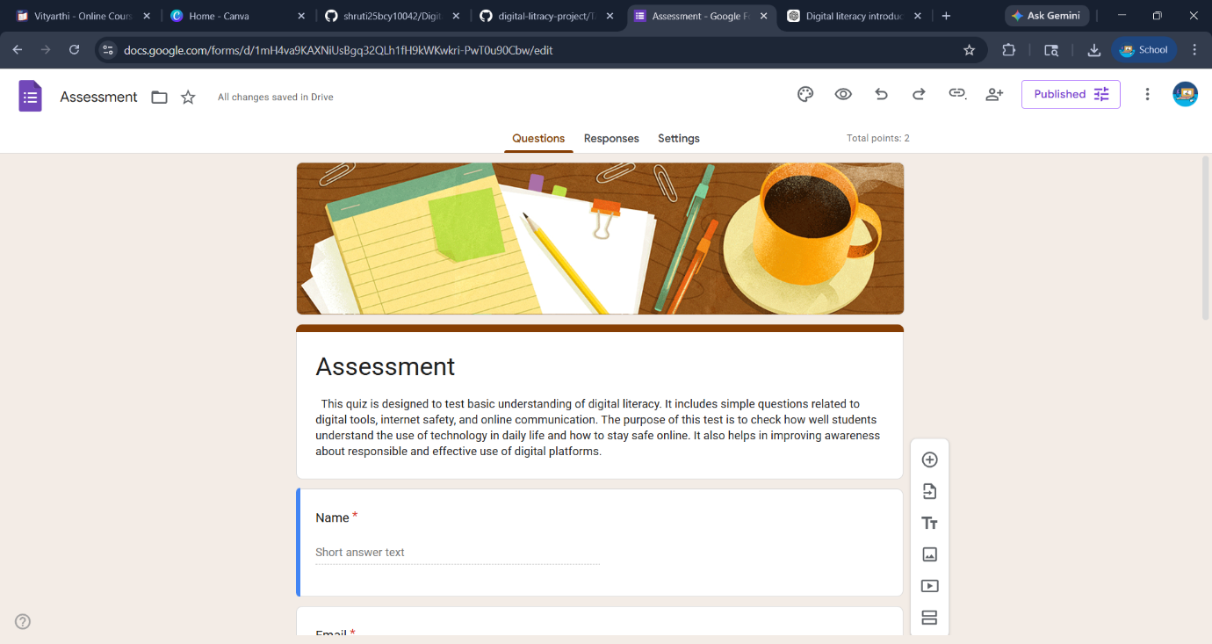

Google Form: https://docs.google.com/forms/d/e/1FAIpQLSefSln8aDqfzPZMz9ivCrhtrfBrDzRZf2O1JLOYwnfWxTm5uw/viewform?usp=dialog

